EXPERIMENT NO 2:
For a given set of training data examples stored in a .CSV file, implement and demonstrate the Candidate-Elimination algorithm in python to output a description of the set of all hypotheses consistent with the training examples
Aim:
To implement and demonstrate the Candidate-Elimination Algorithm in Python for finding the set of all hypotheses consistent with the given training examples.

Procedure:
- Define the training dataset in the program.
- Initialize the Specific Hypothesis (S) with the first positive example.
- Initialize the General Hypothesis (G) with the most general hypothesis (? for all attributes).
- Process each training example:
  - For a positive example, generalize S if needed and remove inconsistent hypotheses from G.
  - For a negative example, specialize G to exclude the negative example while remaining consistent with S.
- Remove duplicate and inconsistent hypotheses from G.
- Display the final Specific Boundary (S) and General Boundary (G).

Program:
# Candidate Elimination Algorithm
import numpy as np

# Training Dataset
data = np.array([
['Sunny', 'Warm', 'Normal', 'Strong', 'Warm', 'Same', 'Yes'],
['Sunny', 'Warm', 'High', 'Strong', 'Warm', 'Same', 'Yes'],
['Rainy', 'Cold', 'High', 'Strong', 'Warm', 'Change', 'No'],
['Sunny', 'Warm', 'High', 'Strong', 'Cool', 'Change', 'Yes']
])

# Separate concepts and target
concepts = data[:, :-1]
target = data[:, -1]
# Initialize Specific and General Hypotheses
specific_h = concepts[0].copy()
general_h = [["?" for i in range(len(specific_h))] for j in range(len(specific_h))]
print("Initial Specific Hypothesis:")
print(specific_h)
print("\nInitial General Hypothesis:")
print(np.array(general_h))
# Candidate Elimination Algorithm
for i, h in enumerate(concepts):
if target[i] == "Yes":
for x in range(len(specific_h)):
if h[x] != specific_h[x]:
specific_h[x] = '?'
general_h[x][x] = '?'
if target[i] == "No":
for x in range(len(specific_h)):
if h[x] != specific_h[x]:
general_h[x][x] = specific_h[x]
else:
general_h[x][x] = '?'

# Remove redundant hypotheses
general_h = [g for g in general_h if g != ['?', '?', '?', '?', '?', '?']]
print("\nFinal Specific Hypothesis:")
print(specific_h)
print("\nFinal General Hypothesis:")
for g in general_h:
print(g)

Output:
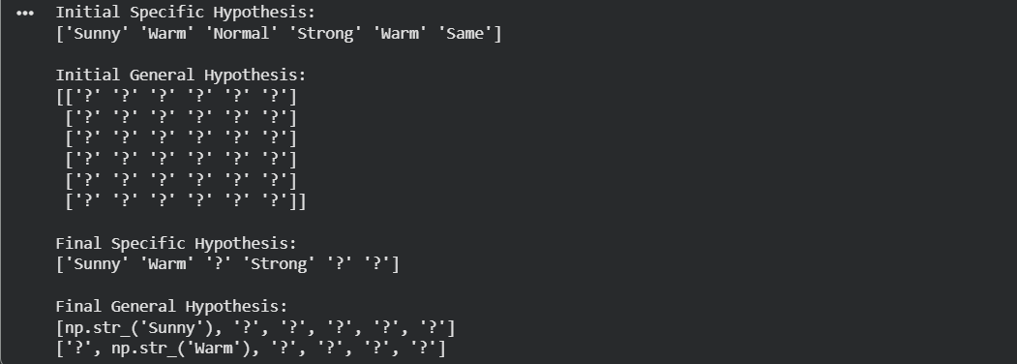

Result:
The Candidate-Elimination Algorithm was successfully implemented in Python. The algorithm determined the Specific Boundary (S) and the General Boundary (G), representing all hypotheses that are consistent with the given training examples. This code runs directly in Google Colab without requiring a separate CSV file.

